A000-Am,C-Taino-Tripointer-Type 2-Anthropomorphic Head-Andesite-1000 CE

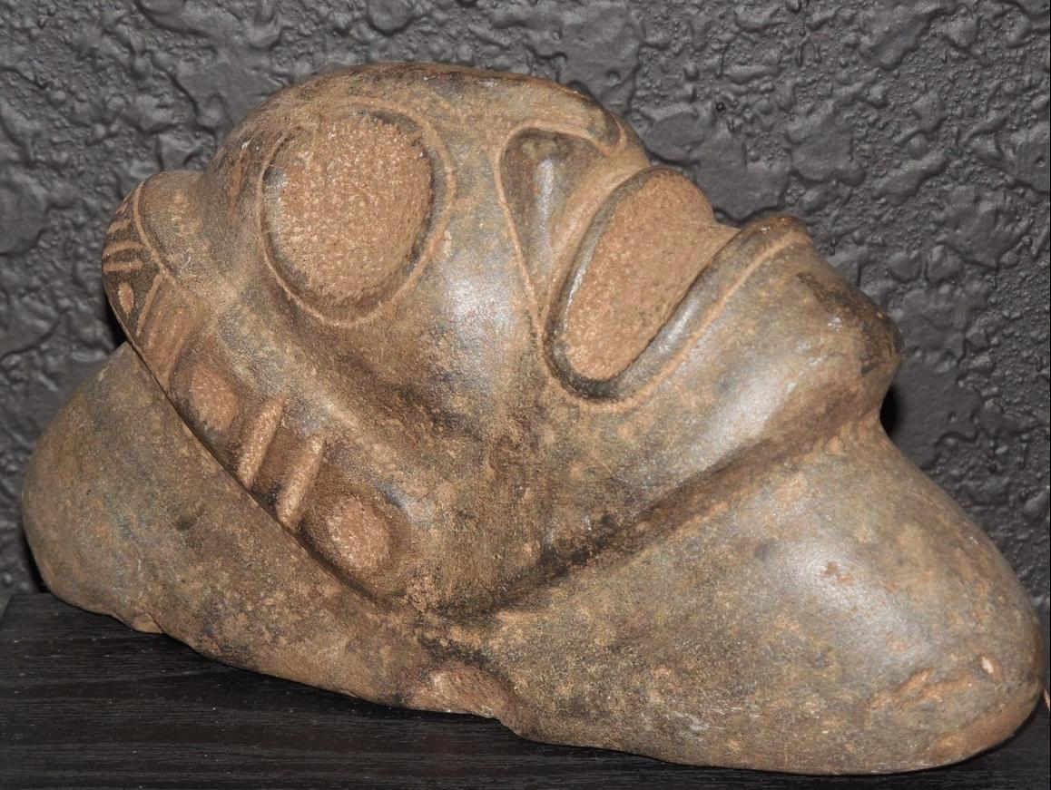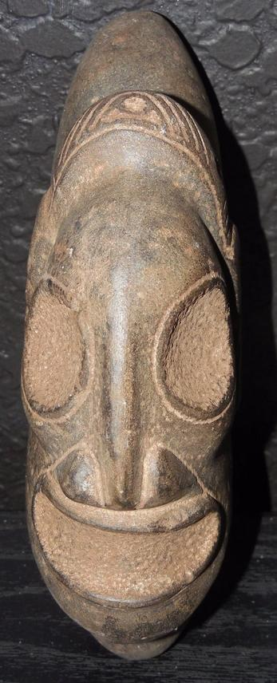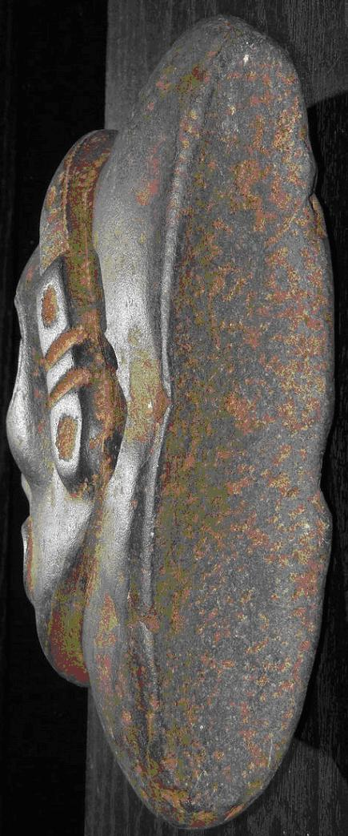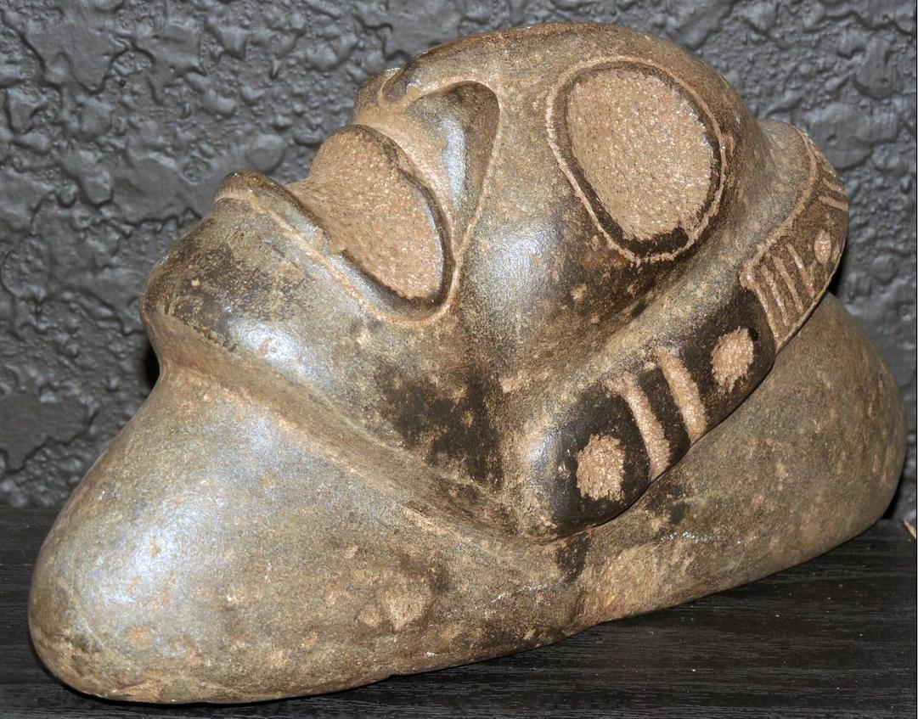

Figs. 1-4. Am,C-Taino-Tripointer-Type 2-Anthropomorphic Head-Andesite-1000 CE

**Case No.: 17**

**Accession No.**

**Formal Label:** Am,C-Taino-Tripointer-Type 2-Anthropomorphic Head-Andesite-1000 CE

**Display Description:**

Anthropomorphic stone head, Fewkes type 2, ovate head with headband, ear spool and open mouth.

**LC Classification:**

**Date or Time Horizon:**

**Geographical Area:** Originally from the Dominican Republic

**Map:**

**GPS coordinates:**

**Cultural Affiliation:**

**Media:**

**Dimensions:**

**Weight:**

**Condition:**

**Provenance:** Originally from the Dominican Republic

**Discussion:**

**References:**